**Lecture 3.1. Practice Questions**

**Q1.a. Factorials**

In mathematics, the factorial of a non-negative integer ***n***, denoted by ***n!,*** is the product of all positive integers less than or equal to n.

**n!** = n * (n-1) * (n-2) * (n-3) * …. * 3 * 2 * 1

The value of 0! is 1.

The following code implements factorials for n from 0 to 5:

|  |  |  |  |  |
| --- | --- | --- | --- | --- |
|  | **number = 5** | | | |
| **Code Line #** | **Executed (Yes/No)** | **Condition**  **(True / False)** | **factorial** | **number** |
| **4** |  |  |  |  |
| **5** |  |  |  |  |
| **6** |  |  |  |  |
| **8** |  |  |  |  |
| **9** |  |  |  |  |
| **10** |  |  |  |  |
| **12** |  |  |  |  |
| **13** |  |  |  |  |
| **14** |  |  |  |  |
| **16** |  |  |  |  |
| **17** |  |  |  |  |
| **18** |  |  |  |  |
| **20** |  |  |  |  |
| **21** |  |  |  |  |
| **22** |  |  |  |  |
| **24** | **factorial =** | | | |

|  |  |  |  |  |
| --- | --- | --- | --- | --- |
|  | **number = 0** | | | |
| **Code Line #** | **Executed (Yes/No)** | **Condition**  **(True / False)** | **factorial** | **number** |
| **4** |  |  |  |  |
| **5** |  |  |  |  |
| **6** |  |  |  |  |
| **8** |  |  |  |  |
| **9** |  |  |  |  |
| **10** |  |  |  |  |
| **12** |  |  |  |  |
| **13** |  |  |  |  |
| **14** |  |  |  |  |
| **16** |  |  |  |  |
| **17** |  |  |  |  |
| **18** |  |  |  |  |
| **20** |  |  |  |  |
| **21** |  |  |  |  |
| **22** |  |  |  |  |
| **24** | **factorial =** | | | |

|  |  |  |  |  |
| --- | --- | --- | --- | --- |
|  | **number = 2** | | | |
| **Code Line #** | **Executed (Yes/No)** | **Condition**  **(True / False)** | **factorial** | **number** |
| **4** |  |  |  |  |
| **5** |  |  |  |  |
| **7** |  |  |  |  |
| **8** |  |  |  |  |
| **10** |  |  |  |  |
| **11** |  |  |  |  |
| **13** |  |  |  |  |
| **14** |  |  |  |  |
| **16** |  |  |  |  |
| **17** |  |  |  |  |
| **19** | **factorial =** | | | |

**Q.1.c. Change (fix) the code in Q1.b. (by marking up the code above) so the factorial variable is set to the correct value. Fill out the table below, after making the change:**

|  |  |  |  |  |
| --- | --- | --- | --- | --- |
|  | **number = 2** | | | |
| **Code Line #** | **Executed (Yes/No)** | **Condition**  **(True / False)** | **factorial** | **number** |
| **4** |  |  |  |  |
| **5** |  |  |  |  |
| **7** |  |  |  |  |
| **8** |  |  |  |  |
| **10** |  |  |  |  |
| **11** |  |  |  |  |
| **13** |  |  |  |  |
| **14** |  |  |  |  |
| **16** |  |  |  |  |
| **17** |  |  |  |  |
| **19** | **factorial =** | | | |

**Q2. Quadratic formula is as follows:**

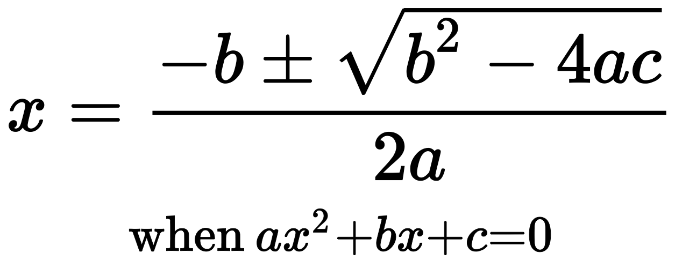

Write, in Python, formula for both values of x, using a variable for each:

1) using +ve sign after -b

2) using -ve sign after -b

Also, give an appropriate name to the two x variables

1. _______________________________________________________________
2. _______________________________________________________________

|  |  |  |  |
| --- | --- | --- | --- |
| **Precedence** | **Left Operand** | **Operator** | **Right Operand** |
| 1 |  |  |  |
| 2 |  |  |  |
| 3 |  |  |  |
| 4 |  |  |  |
| 5 |  |  |  |
| 6 |  |  |  |
| 7 |  |  |  |
| 8 |  |  |  |
| 9 |  |  |  |
|  |  |  |  |

**Q3.** A XOR Bis defined as (A or B) and (not A or not B)

|  |  |  |  |  |  |  |
| --- | --- | --- | --- | --- | --- | --- |
| **A** | **B** | **A or B** | **not A** | **not B** | **not A or not B** | **(A or B) and (not A or not B)** |
| True | True |  |  |  |  |  |
| True | False |  |  |  |  |  |
| False | True |  |  |  |  |  |
| False | False |  |  |  |  |  |